**Litchfield Historical Society**

**Helga J. Ingraham Memorial Library**

**Archives and Manuscripts Processing Manual**

The Litchfield Historical Society’s *Processing Manual* is a training guide for new processing staff, as well as a general reference manual for all staff in matters pertaining to manuscript processing at the Helga J. Ingraham Memorial Library. It details the library's current practices and standards for arranging and describing archival collections in accordance with generally accepted archival principles and specific local practice.

Detailed specifications for accessioning new donations or items found in collections may be found in the Society’s *Registration Manual*; some of this information has been incorporated here for clarity.

This *Processing Manual* also provides general information about the library's accessioning, shelving, classification, and other record keeping practices, past and present, to the extent that such information may be useful in processing or in preparing archives for processing.

The following are guidelines and suggestions, not steadfast rules. The exceptions to these rules are what make the processing of manuscript and archival collections more than a simple clerical task.

**History of Collecting and Cataloging**

The Litchfield Historical Society was founded in 1856. Collecting became a primary function in the 1890s. Around 1900 the Historical Society found its current home in the Noyes Memorial Building. The Society’s collection management function became more structured at that time, and early accession books document its first holdings. From the start, the collections included documents and manuscripts, but little effort was made to systematically catalog them until the 1970s when a graduate student in history and typist were hired as part of a privately funded project to create a card catalog. This first project employed a curatorial approach, describing individual items rather than entire collections, and sometimes arranging papers by type (deeds, invitations, and summonses are some examples) rather than by provenance. The card catalog reflects this, with hundreds of item-level descriptions and only a handful of collection-level descriptions for the collections deemed most significant. No policies were established for creating standardized subject headings or authority files. This cataloging project continued into the 1980s. Though the original student worker had moved on, the typist continued. The project by no means cataloged the entire collection, and the Society’s holdings continued to grow. Earlier staff contributed 14 very basic collection-level records to the National Union Catalog of Manuscript Collections. From the mid 1980s to 2002 (when the Society had no professionally trained archives staff), no catalog records were created for collections. Incoming donations were sometimes accessioned and put on shelves with accession numbers listed on the outside of the container. In other cases, they were not assigned a number but simply boxed and shelved with the deed of gift. In 2002, the Society hired a professionally trained Curator of Library & Archives. Due to lack of funding to purchase software, the archivist used PastPerfect, which the Society already owned and used for tracking membership information, to document incoming collections. Some collections records were imported from an earlier database created during a project to document bound materials. While PastPerfect is a fine tool for holding accession information and single item catalog records, staff determined that it was cumbersome for storing large amounts of data for sizable collections, or for the creation of finding aids. In 2008, the Society received a grant from the Council on Library and Information Resources to catalog its early holdings (materials dating 1835 and older). In 2009, a grant from the National Historical Publications and Records Commission provided funding to create collection level description for uncataloged holdings dating after 1835. Archon, an open-source archival management tool, was installed with funding from these grants, and was used to create finding aids for the collections described with grant funding. This processing manual was also created with funding from those organizations with details specific to those projects. It is updated as the Society moves forward with new tools and procedures.

In 2015, the Society began migration of its finding aids to ArchivesSpace, an open-source tool designed to integrate the best features of both Archon and ArchivistsToolkit. It also began work on an IMLS Sparks! grant to create a single authority file source used both by ArchivesSpace and CollectionSpace (the database used to manage object collections.) This project also resulted in BentoSpace, a single search portal for staff and end-users, as well as a social tagging feature for CollectionSpace. Currently, Archon and ArchivesSpace both remain available, though new collections and edits to existing records are only permitted in ArchivesSpace and a password is required to access Archon. Most the Society’s digital objects are not yet available online as we do not have digital asset management, preservation, or presentation systems. Neither Archon nor ArchivesSpace generate donor forms or paperwork, so PastPefect is still used to generate acknowledgements and deeds of gift.

**Archival Principles**

Processing is the activity whereby archivists arrange and describe records of enduring value to make them accessible. To that end, several principles are employed when arranging and describing collections. They are:

* **The Principle of Provenance (Respect Des Fonds):** Provenance is a fundamental principle of archives, referring to the individual, family, or organization that created or received the items in a collection. The principle of provenance or the *respect des fonds* dictates that records of different origins (provenance) be kept separate to preserve their context.
* **Original Order:** The organization and sequence of records established by the creator of the records. Notes: Original order is a fundamental principle of archives. Maintaining records in original order serves two purposes. First, it preserves existing relationships and evidential significance that can be inferred from the context of the records. Second, it exploits the record creator's mechanisms to access the records, saving the archives the work of creating new access tools. Original order is not the same as the order in which materials were received. Items that were clearly misfiled may be re-filed in their proper location. Materials may have had their original order disturbed, often during inactive use, before transfer to the archives. A collection may not have meaningful order if the creator stored items in a haphazard fashion. In such instances, archivists often impose order on the materials to facilitate arrangement and description.

Later portions of the manual will provide guidance for what to do with collections that were processed without adherence to these principles. Keep in mind that the goal of following these guidelines is to provide access to users. If the original order cannot be discerned and order must be imposed to facilitate access, the archivist may do so.

**Records Handling**

Ideally all archival work will be done on an appropriately large, flat surface which is clean, dust-free, and away from food. It is important that the processor be able to spread out papers and make notes. The same rules imposed upon researchers using the collection are to be followed by staff. Pencils (not pens) should be used for taking notes and labeling folders to avoid inadvertently marking any documents with ink. Staff will wash and dry hands thoroughly before handling materials. Nitrile gloves will be used for handling materials, such as photographs, which could be damaged by handling. Protective smocks are available for staff. No food or drink are permitted while working with records.

Any preservation activities associated with processing should be reversible. Staff should keep the mantra, “do no harm” in mind when making decisions about storage, handling, or any modification to the state of a record. No staples, tape, paper clips, post-it notes, or lamination shall be used on boxes or contents.

Paper clips and other metal fasteners, rubber bands, and, if possible, tape should be removed from documents. File folder inserts or folded sheets of acid free paper can be used for groups of pages that should be kept together. Existing folders should be replaced with legal sized archival folders. Retain any information written on these folders by copying it to a piece of paper in the new folder or photocopying onto archival paper and including it. All folders within a box should be the same size.

Important fragile items that can be damaged by handling should be housed in Melanex enclosures. Whenever possible, folded items should be unfolded and placed in enclosures large enough to house them flat. If the item is brittle and unfolding could result in damage to the document, leave it as is and note that it needs conservation treatment.

Deteriorating originals, newspaper clippings, publications, and thermal fax copies should be photocopied onto archival paper and replace the originals in the file folders. When photocopying originals that will then be discarded, add a target at the bottom that states “[Unstable original photocopied and removed by staff.]” Originals of items with intrinsic value which have been photocopied to reduce handling should be moved to a restricted folder, while the copy is kept in the main folder. Originals deemed to have limited value, such as newspaper clippings or thermal faxes, may be discarded after approval is obtained from the archivist.

Relationships between individual items MUST be maintained. For example, letters should be kept with their attachments and enclosures should be kept with documents and letters. Items that need to remain together within a folder that contains additional items may be contained within a folder enclosure or folded sheet of archival bond paper.

The number of items in each folder will vary depending upon original arrangement as well as limitations of the folders. If there are multiple items in an archival folder, it should be squared off using one of the scored creases at the bottom of the folder. Ordinarily, archival contents of archival folders should not exceed the widest scored crease. If a large folder must be separated when re-housing, separate into subsequent folders and maintain their relationship by noting it on the label (i.e. 1 of 3 folders, 2 of 3 folders, etc.).

Remove any organic material found in the files, such as pressed flowers or paper napkins. If these items are thought to be important to the folder, copy them onto archival paper, place the copy in the folder, and encase the original in a plastic sleeve and transfer to a separate folder.

Remove framed items from the frame if the frame does not contain any significance to the document it holds. Return the frame to the donor or discard.

**Processing**

**Background Research**

It is important for the processor to obtain background information about the person or entity whose records are to be processed. This background knowledge will assist the processor to place the records into the proper context. Background research will also enable the processor to make informed appraisal decisions based on the degree to which the records document significant areas of the creator's activities. Reviewing secondary sources is the best way to learn about the details of an organization's structure or a creator's life. The processor can also obtain information from individuals with knowledge of the subject, including donors of collections.

When secondary sources are unavailable, information can often be gleaned from the collection itself. Notes and photocopies of particularly enlightening background information may be made and kept in the accession file until the finding aid is written.

**General Guidelines**

When the processor is ready to prepare the records for permanent retention and for research use, s/he goes through the records and appraises them, deciding what is of permanent value. Items not found to be archival should be separated out. Depending on agreements made with the originating office or donor, the discarded records will be offered back, or the archivist will see to their destruction. Note that in some cases, papers usually discarded may be retained because they are the only existing documentation.

The following guidelines of what to discard should be kept in mind while processing.

Discard:

* Items which just happen to be among the records which really have nothing to do with the operation of the creating entity or individual creator.
* Tickler, follow up, or suspense copies of correspondence which are duplicates of the original.
* Duplicate copies of documents maintained in the same file.
* Multiple copies of the same letter, form, request, etc. A sample, however, should be selected for preservation.
* Catalogs, trade journals, and other publications that are received from outside institutions, such as federal agencies, commercial firms, and private institutions, and are not covered by the Society’s Collections Policy.
* Working papers and notes which contain no substantive information.
* Drafts of reports and correspondence which contain no new substantive information.

**Separating Special Format Materials**

When items that require special housing (e.g. flat storage for oversized items or audiovisual materials) come with a larger collection, a separation sheet should be prepared listing the items and their storage locations and inserted in the proper place with the collection. File the separation sheet with the collection, replacing the original item(s), and in the files that are being assembled to document the collection. Make sure that the separated items are labeled clearly for easy identification. When creating the finding aid in ArchivesSpace, make sure to add the material to the proper top container and location.

**Arrangement**

Archival records need to be arranged for several reasons. Arrangement makes the information in the collections accessible and provides the basis for description. During arrangement, physical problems are identified so that records can be preserved over the long term. Arrangement, if performed properly, also makes it possible for users to observe the original order of the records, which provides valuable information about how the author created and used the papers.

**Surveying and researching the records**

The first thing the processor will do is to survey the records, gathering basic information about them. Consider this initial survey as a “first pass” examination of the records (this does not mean examine every single document, a sampling should do). If the records are in a state of disarray, the survey will probably take more time, whereas records that have retained a strong original order should be easier to decipher. Budget time accordingly, the end purpose of the survey is to create a plan for processing the collection.

Before examining the records, review any documentation from the accessioning process. Examine the accession files. What information has the donor already conveyed about these records, their usefulness during their active life, and any information they contain? While working with the collection, be very careful to retain the existing order of the records, even if no such order is apparent. Resist the temptation to rearrange records during this first pass. Keep an eye out for any traces of a previous organization, which may have been disassembled at some point. Color-coded file folders, handwriting matches, and pockets of records grouped together by what appear to be chronological or alphabetical arrangements are potential clues. Do not attempt to reconstruct any disassembled arrangement at this stage. Merely make a note of it.

The purpose of research conducted at the survey level is to assist in determining the value and context of the records. Don’t get carried away. Additional research will be completed as necessary during description. While examining the records, begin to pose the following questions and take notes:

• What types of records are present (e.g. correspondence, ledgers, memorandums, photographic negatives, sound recordings, etc.)?

• What years do the records cover?

• What events, circumstances, and activities are documented?

• How were the records utilized during their active life?

• Are the records the result of a special format or technique (e.g. a specific photographic process)? What are the unique characteristics of that technique that should be noted during arrangement and description of the records?

• What are the physical conditions of the records? This may be the time to begin to research any preservation issues associated with the records that are new to the institution (such as what to do with a moldy ledger, or how to detect and prevent “vinegar syndrome” in acetate-based film). Knowledge about the physical needs of the materials will help you to re-house them appropriately as you undertake the processing.

• Is there an existing arrangement or order to the records? Do they fall into natural groupings? If so, what are these groupings based on – format, subject, the person(s) - who created the records?

• Are there noticeable gaps in the records, dates or events for which documentation is conspicuously absent?

• Are there records that should be restricted to some or all potential users, due to issues of confidentiality or security?

• What related records exist within the processing institution’s archives? Within other repositories?

**Level of Arrangement**

A collection can be organized at several levels. Archival arrangement and description is often hierarchical, to this end:

**Collection:**  A collection is a group of materials, authored or assembled by an individual or organization. Examples of a collection might include: the personal papers of a well-known author, the business records of a general store, or photographs and postcards gathered by a collector. We generally use the term “collection” in a broad sense to refer to any group of materials, but the term can also refer in a narrow sense to a grouping of materials gathered by an individual related to a single topic or purpose.

**Series:** Some collections can be broken into series. Series are discreet, naturally occurring groups of records within a collection. Series should reflect the creators’ organization of the materials. In the case of the author’s personal papers, series might include: Correspondence, Diaries, Writings, and Scrapbooks. Series can be further broken down as necessary, into subseries. The author’s Writing series might contain these subseries: Manuscripts, Working notebooks, and Publications.

**Filing Unit:** Generally speaking, a filing unit is a folder or several folders containing several documents grouped together under one heading. Filing units within a collection, series, or subseries will be arranged. Possible arrangements include chronologically, alphabetically, topically, or numerically. Prefer the original order when arranging the filing units. Description can be used to make materials more accessible if the creator’s arrangement scheme is a difficult one. The physical grouping may or may not be reflective of the intellectual grouping.

**Item:** The item is the individual document, whether it is a piece of correspondence, a photograph, or a manuscript, within each filing unit. Avoid devoting too much time to arranging items within file units. In some cases, this will be necessary for providing access to the materials and in others it will not, so use good judgment.

When arranging a collection, the ultimate goal is to make the materials available expediently and efficiently. Respect the organization imposed by the person who created the records. Not only is this sound archival practice, but it will save time. Strive for simplicity. Many collections will be arranged and described as a single collection, without series. All the complexities of the records do not need to be revealed in their arrangement. Description is an opportunity to alert users to the many formats and topics represented in the collection.

**Discarding original order**

Sometimes it is necessary to discard original order so that the records will be accessible to researchers. Do not take this step lightly. Examples of instances where the original order may be discarded are as follow:

• No true order is discernable. After careful examination, the records are exactly what they appear to be – a jumbled mess, thrown into boxes.

• The original order has been completely lost through use or previous attempts to organize the materials. Either it is impossible to recreate the original order or the time or effort it will take cannot be justified.

Sometimes an order may exist that makes little sense to us, but is clear nonetheless. Perhaps a botanist has developed an elaborate numerical code for various plant species and his files are organized according to this code. Resist the temptation to re-file the records under their common plant names. Use descriptive tools to explain the state of the records and make them intellectually accessible as you see fit. You can create an index to the files by common plant name. Sometimes, a creator will file some correspondence alphabetically by correspondent, some chronologically, and some by subject. Do not integrate all correspondence using a single filing system, undoing the creator’s original order. Explain the creator’s arrangement in the description of the correspondence.

**Imposing an arrangement**

When imposing an arrangement there is one rule of thumb – keep it simple! Alphabetical and chronological arrangements will be easy to work with. When creating record series consider the functional and topical groupings that exist within the records.

**Processing Plan**

In some cases, particularly for large or complex collections, it is useful to write up a processing plan, in which you outline the steps you plan to take to process the collection. It does not need to be complicated. For example, you can list the series and subseries you intend to create, identify disparate groups of records that need to be physically brought together (or if it is better not to bring them together, how you will describe them), and address how you will resolve any problem areas. Before proceeding, you can then discuss your plan with the curator. See the archives forms folder here N:\Common Resources\Forms & Tickets\Collections for a blank template.

**Description**

**A. Overview of descriptive tools**

The primary tool used to provide access to materials in archival collections is a finding aid, a detailed guide to a collection, which includes an inventory, usually at the folder level. The level of description will be determined based upon the nature of the materials being described and their expected use. Finding aids are maintained internally and used to help both staff and outside researchers ascertain whether a collection has the potential to yield useful information. In the case of larger collections, the finding aid can help the researcher determine which materials they will need to work with. Finding aids are created using ArchivesSpace, a web-based community sourced archives management tool. An online manual for using ArchivesSpace, along with video tutorials, can be found by logging in to your account at staff.archives.litchfieldhistoricalsociety.org/ and clicking on the “?” at the top right of the screen.

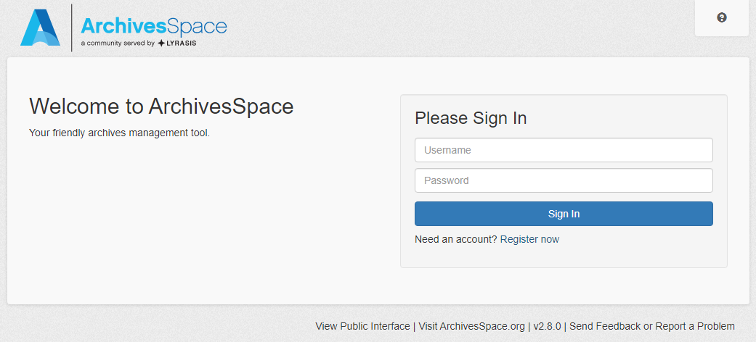

Log in to the help center with your e-mail address and password. Explore the documentation or view the various video tutorials until you feel comfortable exploring the software. A sandbox is also available to help you learn.

While finding aids are required for most collections, very small donations may not require that level of description. In the case of single-item or folder collection, the archivist may choose to publish the accession record in ArchivesSpace until time permits spawning a resource record.

Upon completion of finding aids, they are ingested by [Connecticut’s Archives Online](https://archives-library.wcsu.edu/cao/), a state-wide aggregator of finding aid records. For CAO to ingest a finding aid, it must include title, creator (agent with role creator), abstract, scope/content, and biographical/historical note, all of which must be published. The record must also contain an EAD ID. CAO will not ingest accession records.

**B. Deciding on the level and type of finding aids**

In some cases, a collection level ArchivesSpace record may suffice as the finding aid for the collection. Larger, more complex collections may require detailed finding aids, containing indices, timelines, glossaries, or other additional tools. In general, simpler is better. You may choose to put more effort into finding aids for popular research collections, regardless of complexity or volume. You can always return to a collection and add detail to its finding aid.

Collection level description will allow users to decide whether records warrant further investigation and for the repository to prioritize those which would benefit from additional description. Any uncataloged collection should begin with a collection level record. The required elements for a finding aid outlined below will all be included in the description of each collection. For those collections that will not be processed in more detail in the near future, scope and content notes and administrative history may contain more detail than they would for collections cataloged at a deeper level in order to provide enough information for researchers to make informed decisions about whether to use the collection. As collection level descriptions are added to ArchivesSpace, the archivist will assign an appropriate level of priority for future processing based upon research value, historical significance, and usefulness for in-house programs, exhibits, and publications. The use of the prioritization feature of ArchivesSpace is intended to prevent future backlogs.

In some cases, collections are small, consisting of one item or several small folders. These collections were traditionally housed as “Miscellaneous Manuscripts” and filed alphabetically, though the titles assigned were inconsistent. Some were filed by creator, others by type of document, and others by title. These collections are now housed as “Small Acquisitions” and arranged by accession number. ArchivesSpace will provide easy access by subject, keyword, or date. Frequent additions to the collection will be simple as new acquisitions will be added to the end rather than having to be incorporated into an alphabetical or date arrangement. All new acquisitions that do not contain enough material to fill at least a half Hollinger box will be housed in Small Acquisitions and added to that Classification in ArchivesSpace. The collections in this classification are the ones most likely to have their published description limited to an accession record.

Whenever it is obvious that document was removed from a different collection from where it is currently housed (based on an accession number or institutional record that indicates its original location) it may be returned to the collection it was removed from if feasible. In the past, photographs (regardless of size) were separated from collections and housed together. This is no longer necessary. If a photograph is part of a collection of papers, it **should not** be separated unless there are special conservation or size considerations, in which case the intellectual description will reflect the items proper place within a collection while separation sheets, container records, and location records should be used to identify its physical location. Photographs that are not part of a larger collection should be treated as small acquisitions.

**C. Writing the Finding Aid**

Describing collections in finding aids should be completed using the rules for each required element found in *Describing Archives: A Content Standard*, the latest version of which may be accessed at <https://saa-ts-dacs.github.io/>. Where there is an apparent conflict, follow the local interpretation of DACS rules in this manual.

The Society uses Library of Congress Subject Headings and Name Authority Files to determine the authorized headings for creators and subjects. An ArchivesSpace plug in allows users to easily ingest subject headings and name authorities.

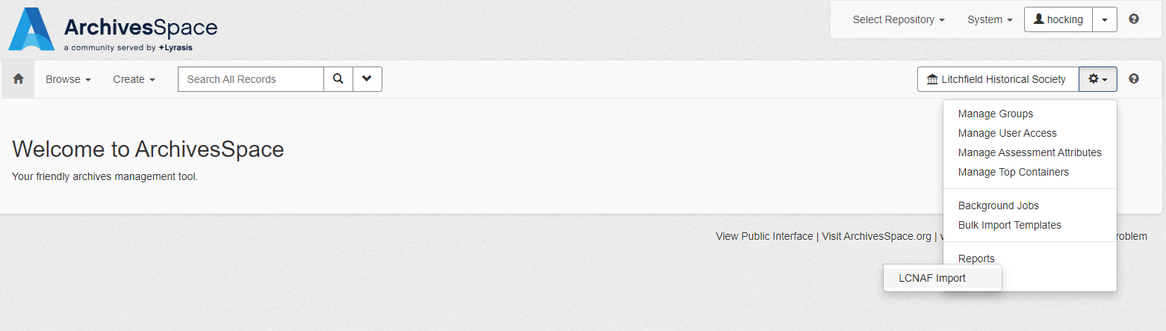

To find the term you wish to include, click the gear icon next to the “Litchfield Historical Society” repository window and hover over “plug ins” at the bottom of the list. LCNAF Import will appear as an option. Select it.

This screen will appear.

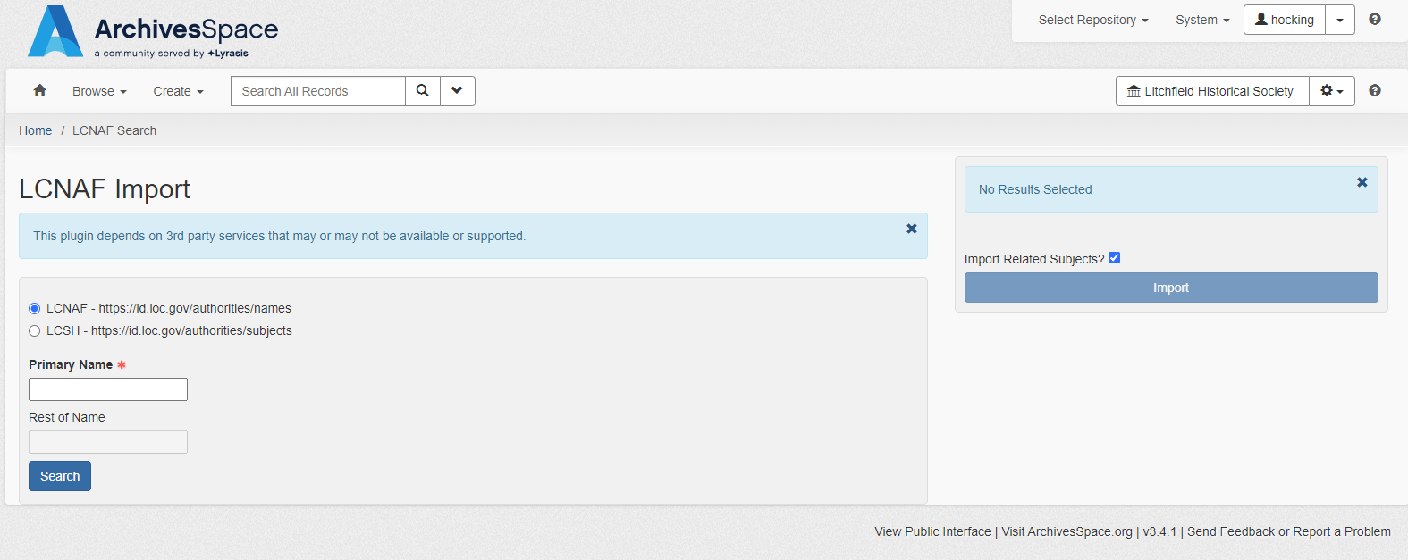

Select authorities or subjects and enter the term in the box. The results will appear below the search box. When you have found the term you wish to import, click “Select.” If you do not want to import related subject terms, uncheck the box above the “Import” button before clicking it. Note that headings and names ingested from LOC default to unpublished, even if the user’s default is set to publish name and subject headings. After the heading imports, you will see the term you imported at the bottom of the screen and can click on it to edit and publish.

For genre of material select the most appropriate term from either the Getty Art and Architecture Thesaurus or Library of Congress Graphic Materials.

Subject and genre terms should be added when they describe a significant portion of the materials or when the items will be described individually. They should also be included for frequently requested formats like photographs. See other collection descriptions for examples and ask the archivist if you have questions. Use the above instructions for importing subject terms from LOC.

If the finding aid is created with funds provided by a grant, provide credit to the granting organization in the notes field.

When creating the finding aid, it is important to be sensitive to past descriptive practices that were racist and/or insensitive to underrepresented populations. *Archives for Black Lives in Philadelphia: Anti-Racist Description Resources* created this guide <https://archivesforblacklives.files.wordpress.com/2020/11/ardr_202010.pdf>. Reference it before you begin processing materials related to marginalized communities. Please note that documentation of these communities may be present in the papers of primarily white individuals.

The authors note, “Use accurate and strong language such as lynching, rape, murder, and hate mail when they are appropriate. Do not let your discomfort with the terms censor the material. It is okay to be uncomfortable with racist material. It is not okay to privilege your discomfort above accurate description.”

For living creators of records, ask them what terminology they use to describe themselves.

Some other important things to remember:

* Provide name access for Black people whenever a name is known.
* Correct any racist legacy description when found or notified by a patron or member of the community. Document these changes in the finding aids.
* Contextualize original description supplied by the creator only when racism is an important context for understanding records. When maintaining racist creator-based description use quotation marks to distinguish between it and archivist supplied description. If you choose not use this language, explain the decision in a processing note.
* Use the term “enslaved” rather than slave to describe someone held in bondage. Use the term “enslaver” to describe someone who held people in bondage.
* Name enslaved people even if the information is incomplete. Record the names by which enslaved people identified as the primary part of their name rather than the name of their enslaver. That information may be added as contextualization to help with identification but should not replace the name of the enslaved person.
* Consider whether the subject headings you are selecting are harmful to the populations they are meant to document.

Read the entire guide for additional points to consider if the materials you are processing document underrepresented groups. It is expected that providing this type of description will require additional labor to provide detail beyond what is typically included in a finding aid.

**D. Labeling**

Whenever possible, be consistent in the labeling of folders and boxes. For collections arranged chronologically, folders should contain the collection title and series and folder numbers on the left and the date of the contents in the center. The name of the creator is to be written on the right. Standardization is nice, but if the arrangement demands a different type of labeling do what is best to facilitate access. To increase efficiency, have a stamp made to label folders for large collections.

Benjamin Tallmadge collection 1818 Jan 1-15

Box 2: Folder 40: Series 3

For collections arranged alphabetically, folders should contain the collection title and series and folder numbers on the left and the name or title which the item is filed under on the right. For example:

Wolcott Family Papers Wolcott, Frederick (1767-1837)

Box 3 Folder 17 Series 1: Correspondence

Boxes should be labeled using label holders with a label inserted containing the name of the collection in bold followed by the accession number. The container number and location should be listed. If the arrangement changes and a new label is required, simply print a new one and insert it into the holder. Example:

**Benjamin Tallmadge collection**

**Box 1/4**

1933-19-0

Series 1: Folders 1-40

**E. Create the Finding Aid in ArchivesSpace**

Begin the finding aid by adding an Accession record in ArchivesSpace. The Accession record will be used to spawn a finding aid, referred to in ArchivesSpace as a “Resource Record.” It should contain any details about the donation or purchase of the collection. Once the accession record is created, click Spawn to create a Resource Record. The Accession Record should remain unpublished when a published resource record exists to avoid confusion in search results.

**Required Elements for Finding Aids:**

**2.1.3 Reference Code:** (ArchivesSpace Identifier Field) Record a local identifier (2.1.3). The Litchfield Historical Society identifiers (also called accession numbers) are generally composed of three parts. The first four digits to the left of the first dash represent the year in which the museum acquired the object; the numbers in between the two dashes represent the number object or library item acquired in that year (the number is given consecutively for both museum objects and library items). The numbers to the right of the second dash indicate the number of objects given by the same donor. Library accessions will always have a 0 in this space (starting in 1995). Collections classified as Small Acquisitions will have two leading zeros 00.1998-17-0. See the Society’s Registration Manual for additional instruction on assigning identifiers.

If a collection is made up of multiple identifiers, use the predominant one. If no one predominates, use the earliest number. Be sure to include information about subsequent donations in the Accruals area and note how the collection was assembled in the Arrangement Note.

**2.2 Name and Location of Repository:** **(ArchivesSpace Resource Record: Notes: Preferred Citation)** Supply the following boilerplate text:

Litchfield Historical Society, Helga J. Ingraham Memorial Library, P.O. Box 385, 7 South Street, Litchfield, Connecticut, 06759. (860) 567-4501. <http://www.litchfieldhistoricalsociety.org>.

**2.3 Title:**

**Collection Level (Add both ArchivesSpace Resource Record Title AND Resource Record: Finding Aid Data: Finding Aid Filing Title):** Supply, at minimum, a *name segment* (2.3.4-2.3.18) and a *nature of the archival unit* segment (2.3.19-2.3.20) in the supplied title. For collection intentionally assembled by the Litchfield Historical Society, follow instructions in DACS rule 2.3.6. We have made a local decision not to use DACS rule 2.3.21 in collection level titles. There has been little consistency in the past in terms of capitalization in collection level titles. Going forward, we will follow the guidelines in DACS and only capitalize proper nouns. When working with existing collections, please edit to remove any unnecessary capitalization in collection titles.

Use DACS rule 2.3.22 to supply a *topical segment* only when a collection documents a single, very specific topical concept, geographic area, or person. If the topic is a person, use DACS rule 2.3.23 to insure the supplied title is structured in such a way as to make clear the topical function of a personal name.

The “Filing Title” field is used for sorting the names of collections for display in search and browse lists. While the Title will be in natural language order, the Filing Title should be created to reflect the desired location for a collection in the sort list. For example:

Title: Benjamin Tallmadge collection

Filing Title: Tallmadge, Benjamin collection

**Series Level**: [ArchivesSpace Resource Record: Component Record] Always supply a *nature of the archival unit* segment (2.3.19-2.3.20)

Supply a *name segment* (2.3.4-2.3.18) for a series in one of two cases. First, when the person, family, or organization primarily responsible for the accumulation, maintenance, and/or use of the materials in the series differs from the name(s) included in the collection-level title. Second, when the actual creator (i.e., author, photographer) of all of the materials in a series is different from the name(s) included in the collection-level title (i.e., when there is one person or organization uniformly responsible for the intellectual content of every item included in the series).

Use DACS rule 2.3.22 to supply a *topical segment* at the series level only when a series

documents a single, very specific topical concept, geographic area, or person. If the topic is a person, use DACS rule 2.3.23 to ensure that the supplied title is structured in such a way as to make clear the topical function of a personal name.

To add a series in ArchivesSpace, you must be in the edit mode of the Resource Record you wish to add a series for. With the collection title selected, click “Add Child” to create a new series.

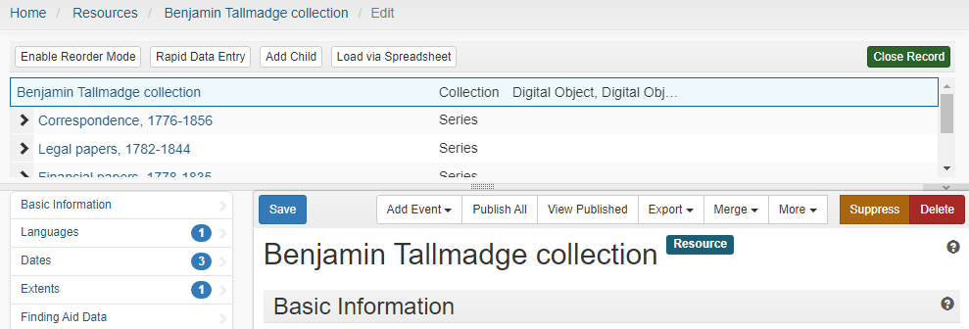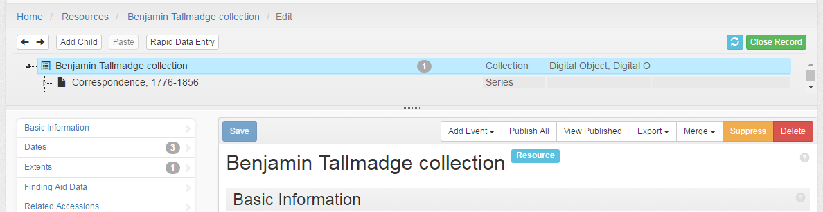

**2.4 Date (ArchivesSpace Creation Dates):** Supply an inclusive date range comprising the dates of creation of the earliest and latest materials in the collection, separated by a hyphen (2.4.6).

Supply bulk dates (2.4.10) (**ArchivesSpace Bulk Dates**) only when that 'bulk' includes more than 75% of the collection materials and when the gap between the bulk dates and outliers is 25 years or more.

(2.4.14) For descriptions of a single item, record exact dates in a consistent and unambiguous fashion, preferably expressed as year-month-day.

Estimate dates whenever possible (2.4.12, 2.4.15); use *undated* sparingly, when estimation is absolutely not feasible; never use the abbreviation *n.d.* (2.4.16).

If dates are estimated, use *circa* to indicate this; always spell out *circa.*

Record exact single dates (2.4.13) at the collection or series level. If recorded, do so in Year Month Day order (2.4.14). Previous practice was to abbreviate all months using their first three letters, with no trailing period. Example: Jan Feb Mar. As per existing DACS guidance we will spell out the month names going forward and edit three letter entries as we update or expand existing finding aids.

If the material being described is a reproduction, record the details about the reproduction, including the date(s) of the reproduction, if known, in the Scope and Content Element (2.4.1).

**2.5 Extent (ArchivesSpace Extents):** At the collection level, record physical extent with number of linear feet.

For small acquisitions, express the number of folders or items.

If a collection includes born-digital material, express the total extent of that material in

Megabytes, in addition to the linear footage. If a larger expression of digital extent (e.g.

Gigabytes) is appropriate, use it. 17 linear feet and 75 megabytes

Round all decimals to the nearest quarter (.25) and never record more than 2 decimal places.

If the linear footage for a collection is less than 1.0, record a zero (0) in front of the decimal, e.g., 0.75 linear feet, ***not*** .75 linear feet.

Use the Yale calculator to determine linear feet:

<https://beinecke.library.yale.edu/research-teaching/doing-research-beinecke/linear-footage-calculator>

**2.6 Name of Creator(s) (ArchivesSpace Agents):** Record, at minimum, the name(s) used in the name segment of the supplied title (2.6).

If the repository is responsible for the creation of an intentionally assembled collection and not noted in the name segment (2.3.6), record the name of the repository here.

Also record others named in the Administrative/Biographical History Element if they have a significant role in the provenance of the collection (2.7). Do not record here those whose role is simply responsibility for creation of the intellectual content of materials in the collection.

Record names as they appear in the Litchfield Historical Society’s name authority file, or if not found there, the Library of Congress Authorities. DACS chapters 10-12 provide instructions for formulating the name in an authorized way when the name is not found in LC.

If the creator is not known, select “unknown” from the name authority file. If you do not do this, the record will not be harvested by CAO. All finding aids must have at least one creator.

Record as many separate names as necessary to capture responsibility for the archival provenance of the materials being described.

To provide ease of access, when describing a deed, the party listed as the Grantor on the document shall be listed as the creator. Consult with the archivist if you encounter another type of document for which it is difficult to assign a creator.

**2.7 Administrative/Biographical History (ArchivesSpace Agents: Notes):** Use DACS rules 11.2 and 2.7.11-2.2.21to provide succinct background information on individuals or families named either in the Title (2.3) or Name of Creator(s) (2.6) elements.

Use DACS rules 11.2 and 2.7.22-2.7.22.33 to provide succinct background information on corporate bodies named either in the Title (2.3) or Name of Creator(s) (2.6) elements.

The less well known a person is, the more information you should provide in the Biography/ Historical Note field.

**3.1 Scope and Content (ArchivesSpace Resources:** **Notes: Scope and Contents)** Use the bulleted list of scope and content information components under "Purpose and Scope" in DACS chapter 3 to guide composition of the content of this element. Evaluate the need for the inclusion of additional information based on its importance in assisting users in assessing the relevance of the collection. The scope and contents notes should be especially thorough and detailed for those collections that will not receive additional box/folder/item level description.

At the collection level, compose a brief initial paragraph that summarizes in the first sentence the nature of the collection and the role and/or importance of the creator(s) (e.g.

"The personal papers of [named individual or family] ...," or "The organizational records of [named corporate body] ....” The Identifier (accession number) and the extent statement (in linear feet) should be reiterated in a logical place at the beginning of the Scope and Content note. The final sentence of this paragraph should summarize, at a broad level, the types of materials in the collection. Follow this, if necessary, by additional paragraphs providing more detail about important aspects of the collection. Write in complete sentences.

In cases where DACS rule 2.3.19 was used to supply the nature of the archival unit segment of the collection title, use the same terms in the first sentence of the first paragraph, in place of papers or records (e.g., "The photographs and diaries of [named individual or family] .... ").

For intentionally assembled collections, craft a first sentence in the first paragraph that appropriately reflects the title of the collection (e.g., "This collection documents the history of Litchfield, Connecticut, with particular emphasis on .... ").

**3.2 System of Arrangement Element (ArchivesSpace Resources:** **Notes: Arrangement):**

Insert the following sentence, if the collection is arranged into series, followed by a listing of each series, using Arabic numbers to designate each series.

*The collection is arranged in 3 series:*

*1. Correspondence*

*2. Photographs*

*3. Organizational records*

If the collection is not arranged in series, compose a sentence or two characterizing the primary arrangement scheme.

Example: The collection is arranged chronologically.

If original order has been maintained or enhanced in some way during arrangement, add a sentence indicating why the original order was significant. If a usable order was imposed during processing, in the absence of a meaningful original order, add a sentence indicating this.

Example: The collection is arranged chronologically, as it was received from the donor. The sole exception is the correspondence with certain individuals that was maintained separately by the creator, for unknown reasons, from the overall chronological filing sequence of her papers. These files have been arranged alphabetically by surname following the chronological sequence of correspondence.

**4.1 Conditions Governing Access (ArchivesSpace Resources: Notes: Conditions Governing Access): If there are any restrictions, check the “Restrictions” box in ArchivesSpace Resources: Basic Information.**

If there are no access restrictions, use the following sentence:

The collection is open for research.

If there are restrictions, use the boxes provided to note the date the restrictions begin and end. Chose the type of restriction (Donor Imposed, etc.) and then use the notes field to add as many of the following sentences necessary to provide information about the restrictions:

Access to [state relevant part of the collection] requires written permission of the donor. Contact the reference archivist for further information.

Access to [state relevant part of the collection] requires that the

researcher sign a non-disclosure agreement.

Access to [state relevant part of the collection] is restricted until [date provided].

**4.2 Physical Access (ArchivesSpace Resources: Notes: Conditions Governing Access): If there are any restrictions, check the “Restrictions” box in ArchivesSpace Resources: Basic Information.** If the original materials may not be used for preservation reasons, leave the dates blank and select “Restricted- Fragile” as the restriction type and add the following sentence to the notes field:

Originals are not available due to fragility. Use photocopy [or digital surrogate].

**4.4 Conditions Governing Reproduction and Use (ArchivesSpace Resources: Notes: Conditions Governing Use):** At minimum, provide one of the following statements concerning copyright, depending on the situation in a specific collection:

Copyright has been transferred to the Litchfield Historical Society for materials authored or otherwise produced by the creator(s) of this collection. Copyright status for other collection materials is unknown. Transmission or reproduction of materials protected by U.S. Copyright Law (Title 17, U.S.C.) beyond that allowed by fair use requires the written permission of the copyright owners. Works not in the public domain cannot be commercially exploited without permission of the copyright owners. Responsibility for any use rests exclusively with the user.

Unpublished materials authored or otherwise produced by the creator(s) of this collection are in the public domain. There are no restrictions on use. Copyright status for other collection materials is unknown. Transmission or reproduction of materials protected by U.S. Copyright Law (Title 17, U.S.C.) beyond that allowed by fair use requires the written permission of the copyright owners. Works not in the public domain cannot be commercially exploited without permission of the copyright owners. Responsibility for any use rests exclusively with the user.

Copyright is retained by the creator(s) of this collection for materials they have authored or otherwise produced. After the lifetime of the creator(s), copyright passes to the Litchfield Historical Society. Copyright status for other collection materials is unknown. Transmission or reproduction of materials protected by U.S. Copyright Law (Title 17,

U.S.C.) beyond that allowed by fair use requires the written permission of the copyright owners. Works not in the public domain cannot be commercially exploited without permission of the copyright owners. Responsibility for any use rests exclusively with the user.

**4.5 Languages and Scripts of Material (ArchivesSpace Resources: Basic Information):** Enter the appropriate language in the Languages sub record. If there are multiple languages, supply a sentence listing the languages and, if relevant, scripts of the collection materials in the Language of Materials note.

Example: Collection materials are in English, Spanish, and Vietnamese.

If material in a specific language(s) is only extant in small quantities, give an indication of this in the sentence.

Example: Collection material is in Spanish and Russian, with a small amount of material in English.

**4.6 Finding Aids: (ArchivesSpace: Resources: Notes)** See rules 4.6.2-4.6.5 to record information about existing finding aids. If the materials being described are already included in the Society’s card catalog, add a note use the following sentence:

Item level description is available in the Society’s card catalog.

Add this to the “Other Finding Aids” field. If the existing descriptive tool exists in a digital format or is easy to scan, link it to the collection as a digital object at the appropriate point in the finding aid.

**5.1 Custodial History (ArchivesSpace: Resources: Notes: Custodial History):** If information about the custodial history of the collection between its maintenance and use by the donor and its acquisition by the Litchfield Historical Society is important to future users of the collection, compose a succinct paragraph summarizing the relevant information.

**5.2 Immediate Source of Acquisition (ArchivesSpace: Resources: Notes: Immediate Source of Acquisition):**

Open an Immediate Source of Acquisition note and add Source of Acquisition in the Label field. Add the name of the donor in Text: Content field in natural language order, for example:

Emily Noyes Vanderpoel

To record the method of acquisition, open another Immediate Source of Acquisition note and enter Method of Acquisition in the Label field. In the Text: Content field, note how the collection was acquired. Examples:

Gift

This collection was received in four major accessions, with several smaller additions.  The first came in 1921, with the death of Mary Perkins Quincy.  The materials which had been arranged by Quincy were accessioned as 1921-2-1 through 1921-02-15.

**5.3 Appraisal, Destruction, and Scheduling Information (ArchivesSpace: Resources: Notes: Appraisal):** If possible**,** provide in a succinct paragraph as much information as possible about why the collection was brought into the Litchfield Historical Society. Consult with the archivist if documentation is not available in the collection file.

Additionally, if the decision was made not to accept certain types of material from the donor, provide this information.

If during processing archivists at Litchfield Historical Society made decisions about removing significant amounts of material from the collection (e.g., material was out of scope, sampling), provide the rationale for that decision and enough information so that future researchers can understand the relationship of what was removed to what remains in the collection.

Example: The collection originally included four linear feet of

financial information, primarily checkbook stubs and monthly bank

statements. During processing, in order to reduce the amount of

information deemed inessential for long-term retention, the final

bank statement for each year was retained and others discarded.

Also, checkbook stubs were sampled, with one random book of stubs

retained for every five years.

**5.4 Accruals (ArchivesSpace: Resources: Notes: Accruals):** Take information from donor agreements, records schedules, and institutional policy. If known, indicate whether further accruals are expected. When appropriate, indicate frequency and volume.

**6.3 Related Archival Materials (ArchivesSpace: Resources: Notes: Related Materials):** Note the existence and provide links if available of other materials only if they are closely related either in this repository, another repository, or elsewhere (6.3). List collections held by the Litchfield Historical Society first. Use the Existence and Location of Copies note to designate if transcriptions exist for the collection being described (6,2).

The collections contained in the Helga J. Ingraham Memorial Library are often part of larger family collections which include many related objects of material culture including artwork, clothing, personal artifacts, tools, and other items which are cataloged and housed separately as part of the museum collections. In an effort to make researchers more aware of these resources and that they can learn the most from a combination of documentary evidence and material culture, finding aids should include Related Materials notes for related artifacts. Search the artifact database and consult with the curator to determine related artifacts.

**7 ArchivesSpace: Resources: Notes: Preferred Citation:** Supply the following boilerplate statement regarding the format in which the Litchfield Historical Society prefers researchers to cite archival collections (replace the bracketed parts with information relevant to the collection you are describing):

[Name of collection] ([Collection number]), Litchfield Historical Society, Helga J. Ingraham Memorial Library, P.O. Box 385, 7 South Street, Litchfield, Connecticut, 06759.

Use the General note with the label Related Materials to include information about museum objects related to the collection being described. Consult with the Curator of Collections to determine appropriate materials.

Also use the General note with the label Other Descriptive Information to include information about grants and sources of funding for processing of the collection.

A content standard for a processing note is not included in DACS. **7.1.8 Processing Information:** If the processor feels it would be helpful to future researchers or staff, compose a succinct paragraph providing an overview of the strategy that was used during processing of the collection. Add this in the “Notes” section under “Processing Information.” Be aware that if processing information is added in the “Basic Information” section of the resource record, it will not be visible in the public interface. To make processing information available to the public, add it in the “Notes” section.

Example: This collection received a basic level of processing within a

year after it was received by the Litchfield Historical Society. This included

re-housing in archival boxes and minimal organization. Collection materials were not re-foldered. Descriptive information is drawn in large part from information supplied with the collection and from an initial survey of the contents. Folder titles appearing in the Inventory section of the finding aid are often based on those provided by the creator or previous custodian. Titles have not been verified against the contents of the folders in all cases. When folder labels contained little or no information, processing staff supplied titles based on a cursory examination of folder contents and appropriate national content standards. Additional processing may be done in the future.

**8 Finding Aid Author: ArchivesSpace: Resources: Finding Aid Data: Finding Aid Author:** Indicate the name of the person(s) who processed the collection and provide the year in which processing was completed. Add the date the finding aid was created in the Finding Aid Date field. If the finding aid has been revised, state this in the Revision Statements sub record.

Example: Processed by Ima Archivist, 1992. Description revised, 2005.

**Using ArchivesSpace Bulk Import Templates**

When adding a large number of accessions, or describing a very large collection, it may be most efficient to use the templates for bulk import available when logged into the staff interface at:

<https://staff.archives.litchfieldhistoricalsociety.org/bulk_import_templates>

Completed templates used in the creation of accession records and resource records are located here: N:\Common Resources\Ingraham Library\ArchivesSpace_Templates. It is acceptable to save one of the existing templates with a new name and modify it for the collection you are working on.

It is still necessary to include all required elements when using the import templates. It is also important to use lower case when filling in fields that have a pulldown list of options in the staff interface, such as “date type” as errors result when capital letters are used in these fields.

**Other DACS Elements Not Covered in this Manual:**

Processors identifying a need in a specific description for the use of a DACS element not covered in this manual should consult with the archivist.

Definitions from *A Glossary of Archival and Records Terminology* byRichard Pearce-Moses located at <https://www2.archivists.org/glossary>

DACS to EAD to MARC table:

https://saa-ts-dacs.github.io/dacs/09_appendices/03_appendix_c_crosswalks.html#dacs-to-ead-and-marc

LOC Authority files:

<http://authorities.loc.gov/>

OCLC Fast Subject Headings:

https://fast.oclc.org/searchfast/

Getty Art & Architecture Thesaurus Online:

http://www.getty.edu/research/tools/vocabularies/aat/index.html

**Note about the manual:**

This processing manual was created based upon local history and practice as well as several finding aids, processing manuals, and guidelines which were used as examples. In some cases, the wording is taken directly from them. They include:

Antracoli, Alexis A. et al., “Archives for Black Lives in Philadelphia: Anti-Racist Description Resources.,” Antiracism Digital Library, accessed May 1, 2024, https://sacred.omeka.net/items/show/408

St. Johnsbury Athenaeum Archives *Archives Processing Manual* http://datadrivenarchives.pbworks.com/f/Processing+Manual+St.+Johnsbury+Athenaeum.pdf

M. E. Grenander Department of Special Collections and Archives *Accessioning and Processing Manual* https://archives.albany.edu/web/manual/.

Center of Southwest Studies *Special Collections Archival Procedure Manual* accessed at <http://swcenter.fortlewis.edu/tools/flcArchivalProcedureManual.htm> in 2016.

Sample finding aid provided by William E. Landis for the SAA Workshop *Describing Archives: A Content Standard* presented March 27, 2009, Cambridge, MA.

Stockting, Bill Access to Archives *A2A- Guidelines for Collection Level Description* <http://www.nationalarchives.gov.uk/documents/cat_guide_colln.pdf>